**Kickstarter Analysis- crowdfunding service**

1. **Given the provided data, what are three conclusions we can draw about Kickstarter campaigns?**

There are three statistics we derived from data provided as given below

* Category
* Sub-category
* Outcomes based on Launch date

**Category Stats**

Based on category stats 3 out of 9 were more successful then the others which are :-

1. Music
2. Theatre
3. Film & Video

Music category was more successful with 77.14 % success rate , followed by Theatre with 60.23 % and Film & Video with 57.69% success rate

The Other potential Kickstarter was photography with 46.82% Success rate

The least successful category is Journalism with 0 successful count

**Sub-Category Stats**

Based on Subcategory stats below are the observations derived from data

Classical Music , electronic Music , metal , pop & Rock were all successful with 100 % success rate

Jazz surprisingly did not had any success and at bottom in Music category with 100 % failure

Second most successful category Theatre did well in sub category called Plays with 65.10 % success rate which also is the King of all Kickstarters with total of 1066 having 694 as success , 353 as failed and 19 as live

Food Trucks is the worst kickstarter with highest count of failure count after Plays but Plays has more success rate then failure due to higher number of successful counts

Hardware is the most successful with 140 successful count and 0 failure count among all technology kickstarter projects.

Animation and drama are the worst sub category with 100 % failure count from one of top 3 most successful category Film & Video.

Refer Pie Chart for deep insight pasted below from extra Graph in excel-challenge sheet.

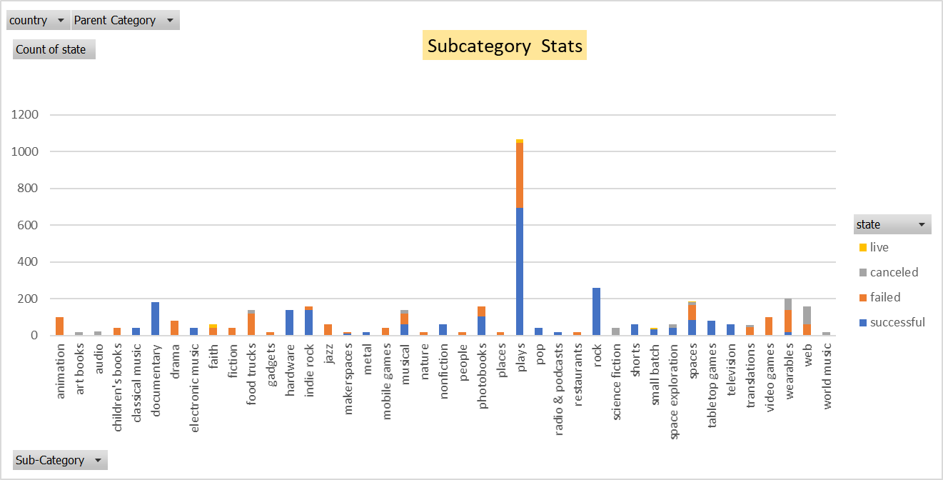

**Outcomes based on Launch Date**

Based on data provided Feb and May are the best time to Launch kick starter project with the success rate of 60.30 % and 60.62 % respectively

Dec is the worst month with 44.05 % success rate

1. **What are some limitations of this dataset?**

The data is not recent means it’s missing information for 2018 , 2019 and 2020 , also only 4114 rows are provided which is very less data to do stats analysis for Kickstarter Projects.

1. **What are some other possible tables and/or graphs that we could create?**

We can create different other tables and/or graphs using data provided which are :-

* Relationship between Parent category with success rate for each country
* Relationship between sub category with success rate for each country
* Relationship between backers and goals for each category
* Relationship between backers and goals for each sub-category
* Relationship between Kickstarter campaign period and its success rate
* Relationship between subcategory successful % rate Pie Chart

**Relationship between subcategory successful % rate Pie Chart**